Name; Hitekani
Surname; Masingi
Course name; Data Sciences
Student Number: 2805001446

1.Upload Dataset
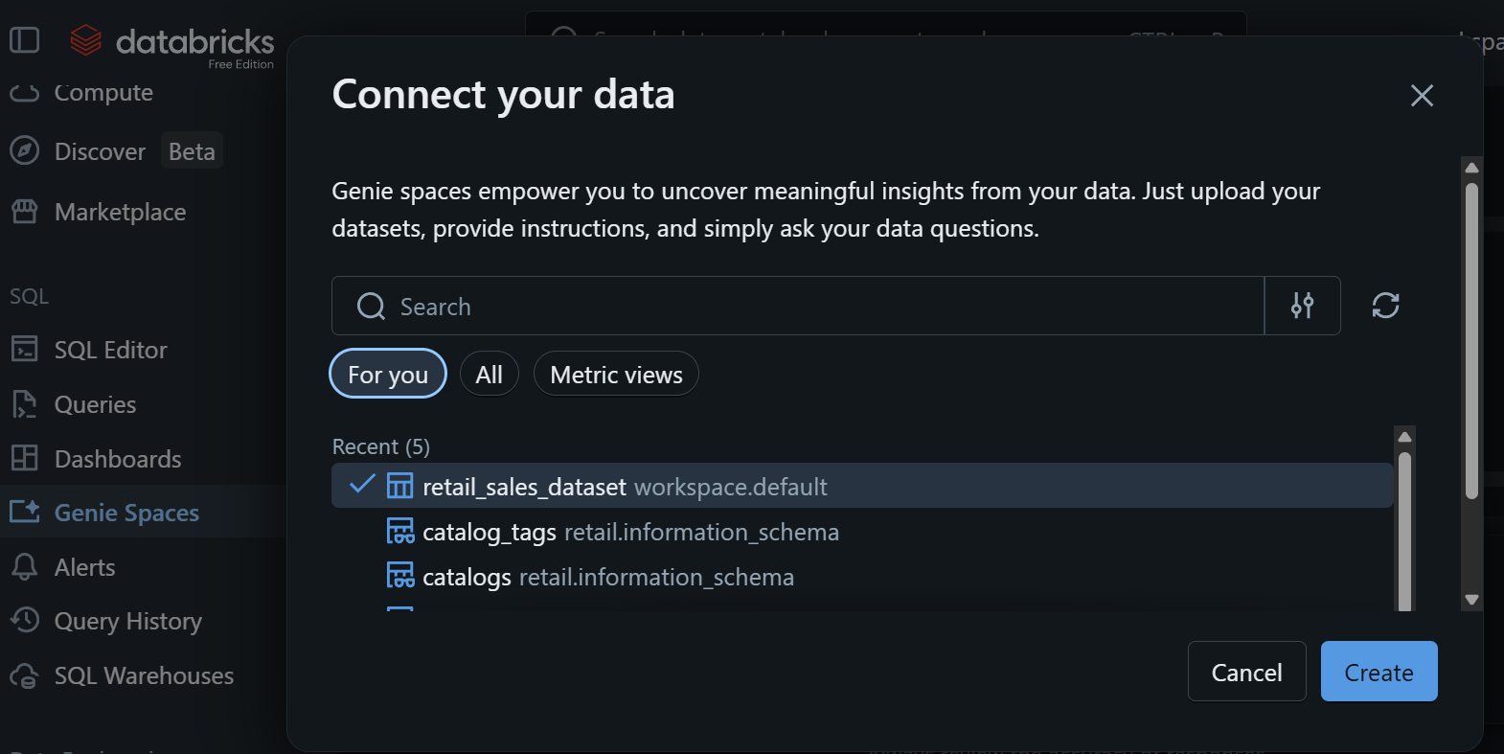

2.Review Dataset
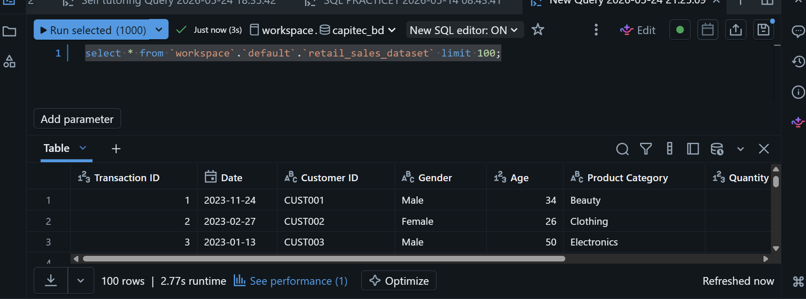

3.Create data Agent
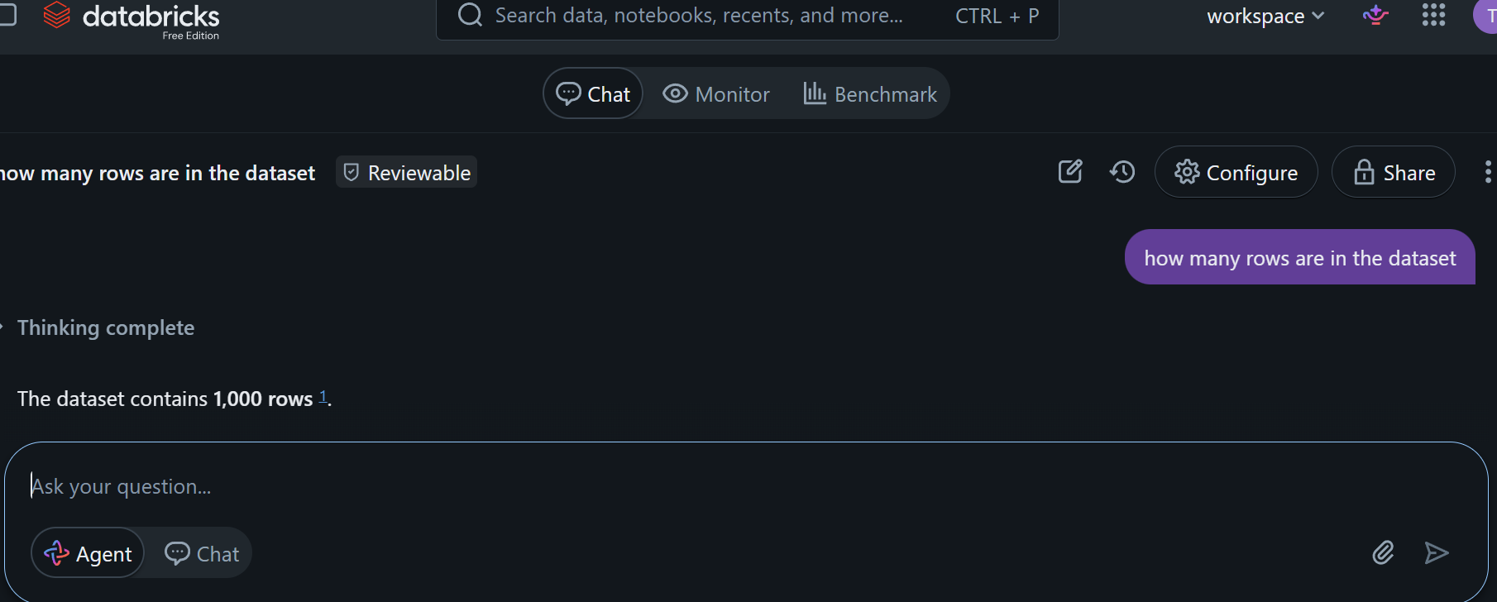
4. Write your own Instructions
- The role of an agent
- It gives accurate information of business insights and helps business make better decisions.
- What questions should the Agent answer.
- Which dataset to use.
- User agent support
- Data usage type
- Handling incomplete data.

5, The 10 Questions
5.1 Which gender has the highest revenue.
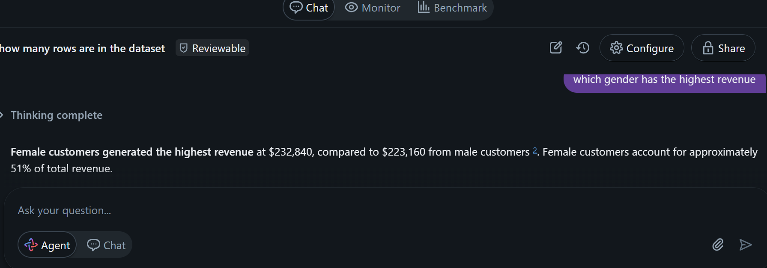

5.2 What is the total sales and the most common trend on sales.

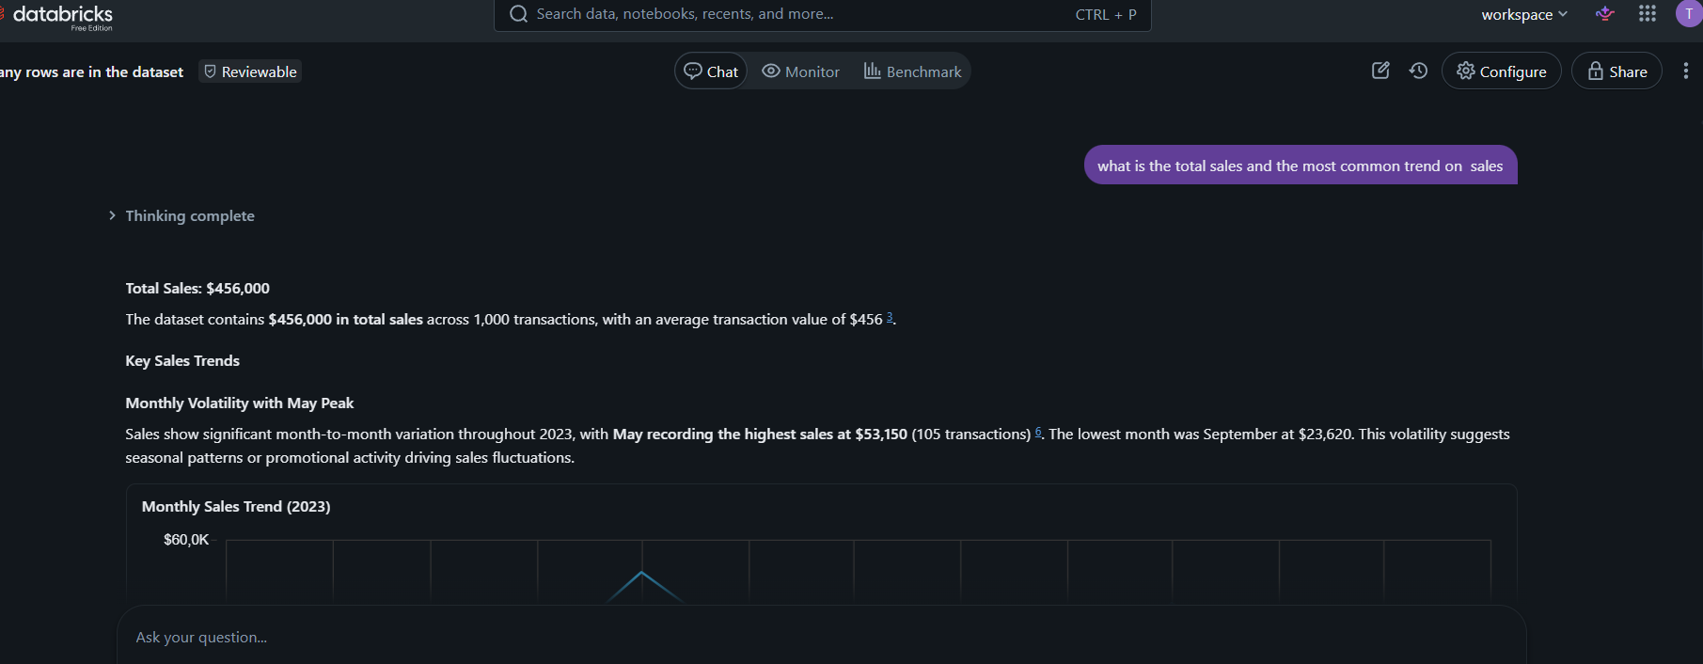

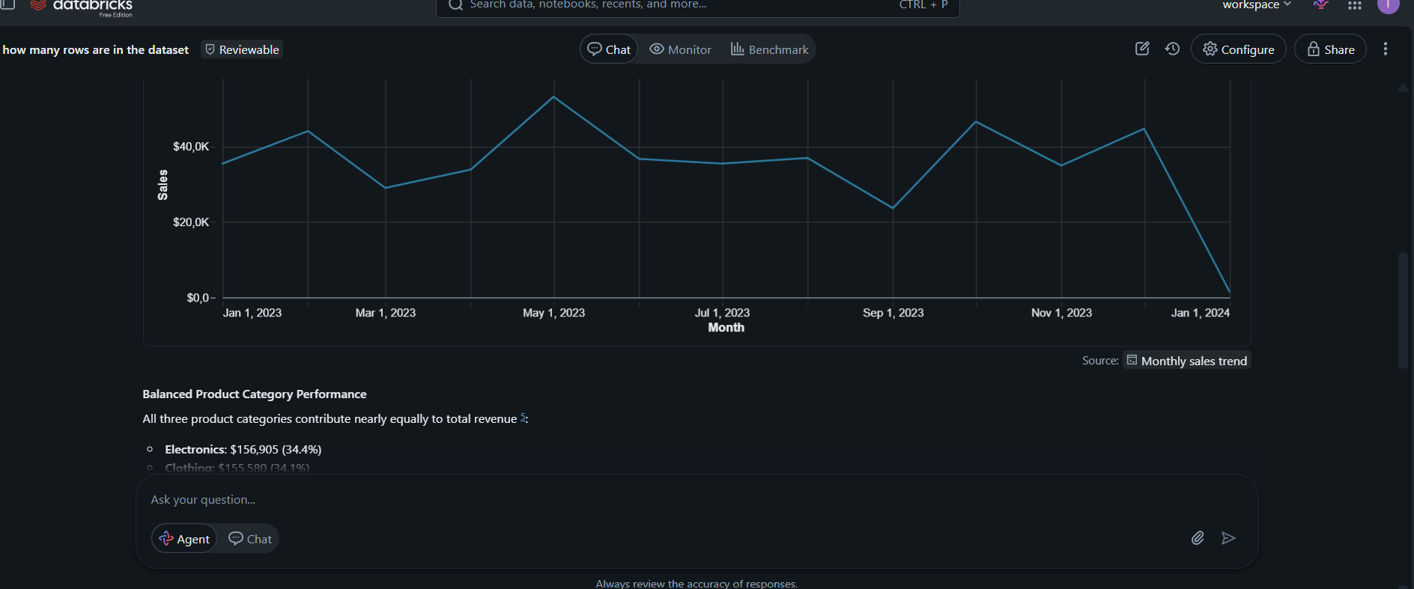

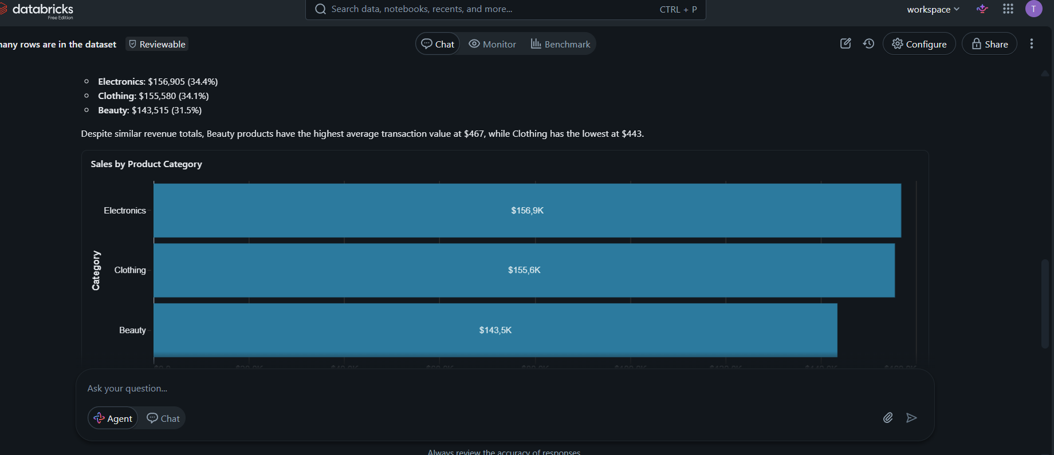

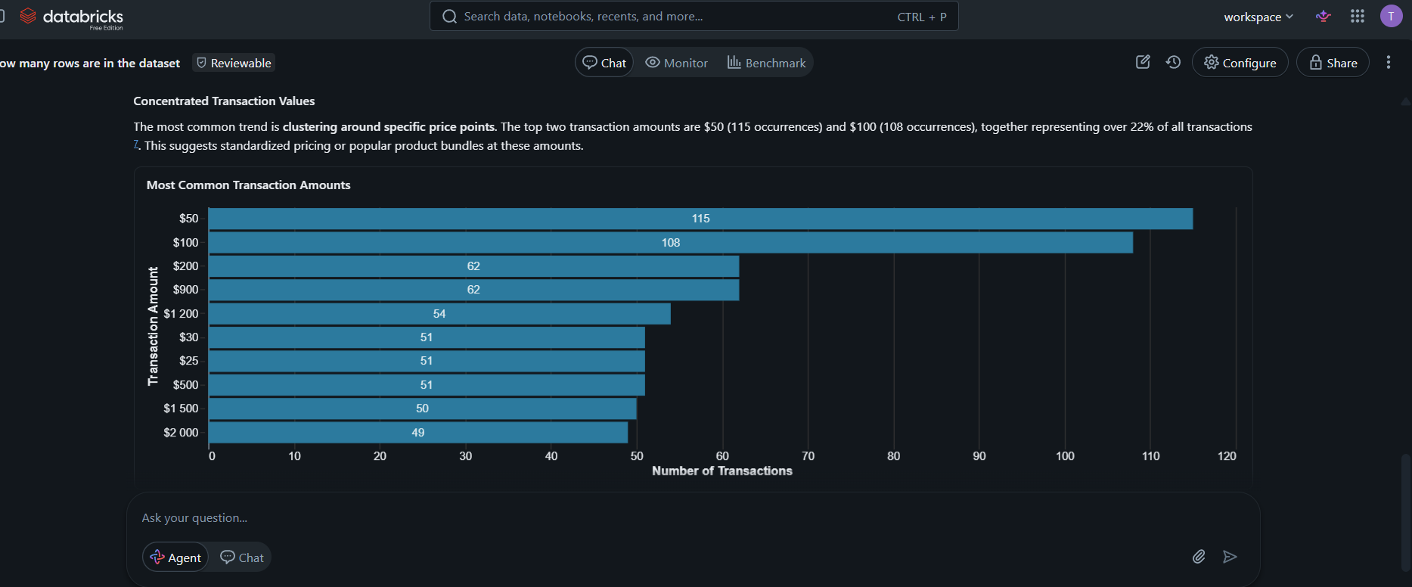

5.3 Which products sales the most ,also which product is on average sales and which product have low sales products.
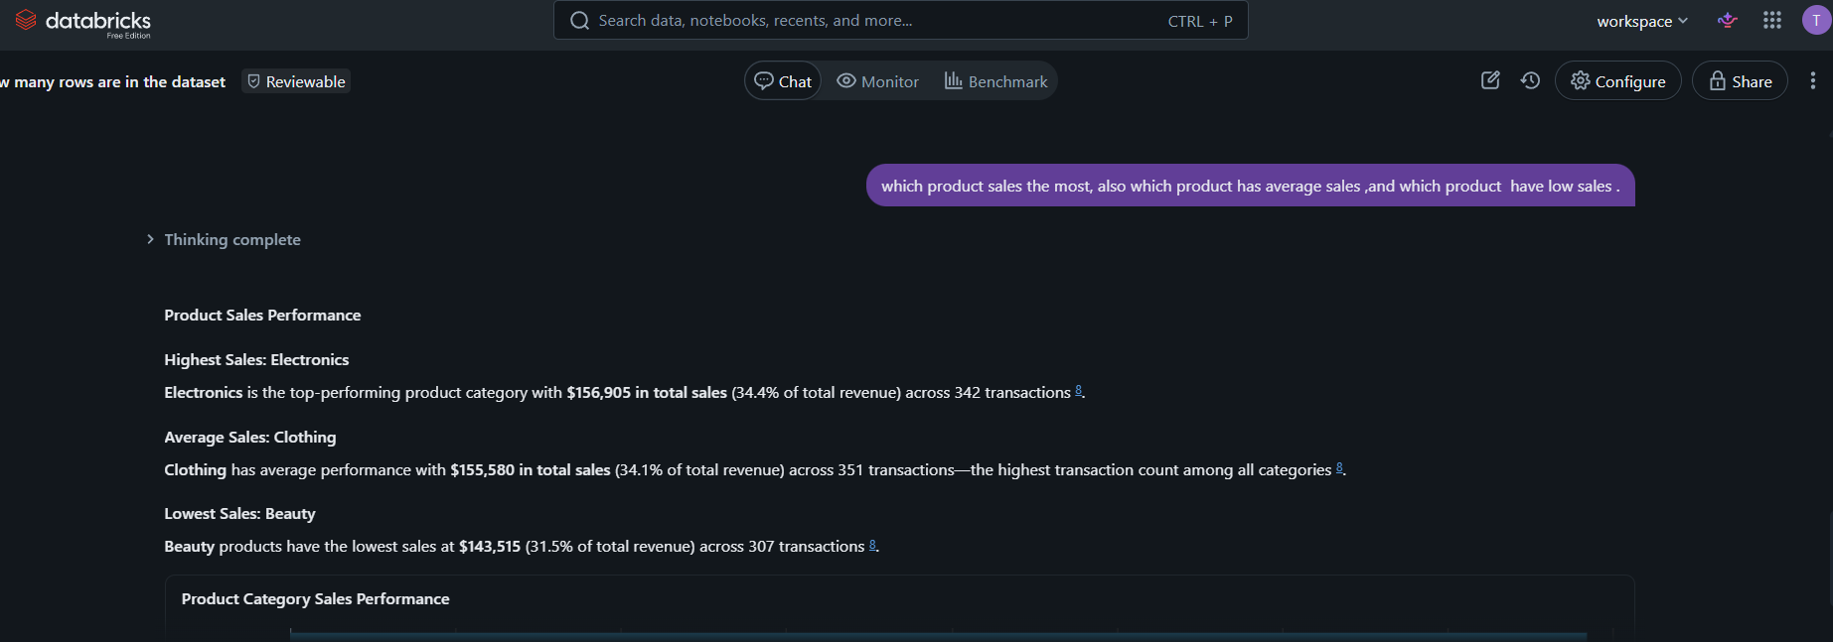

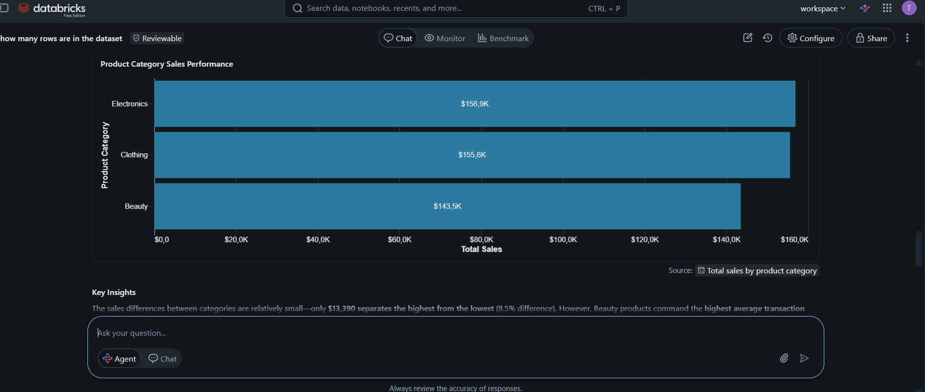

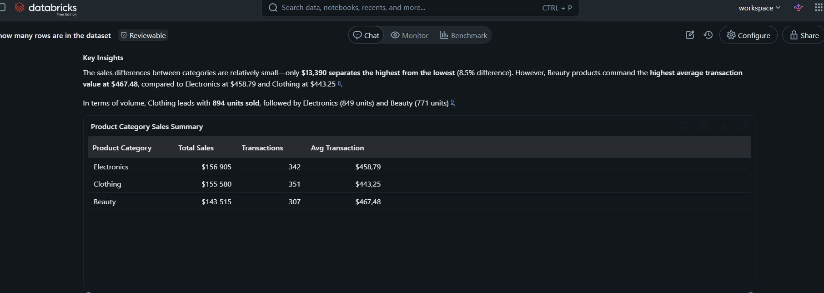

5.4 Which products sales the most based on gender category.
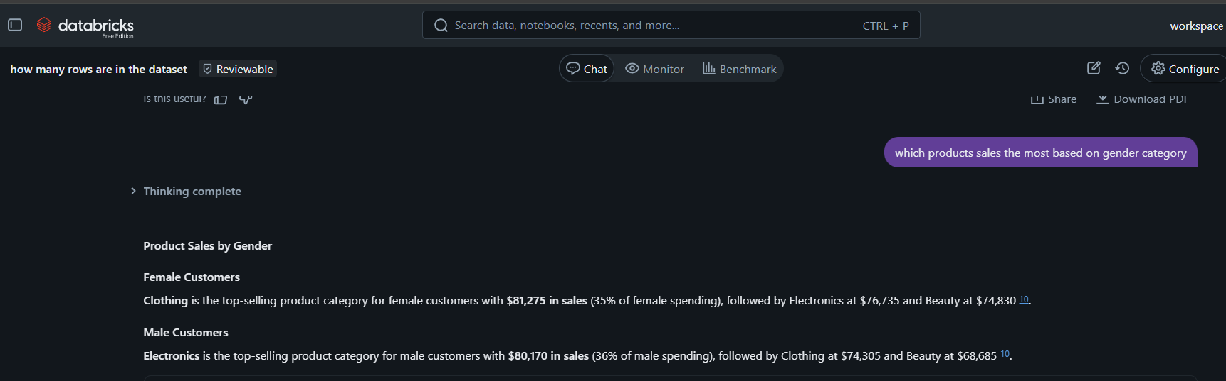
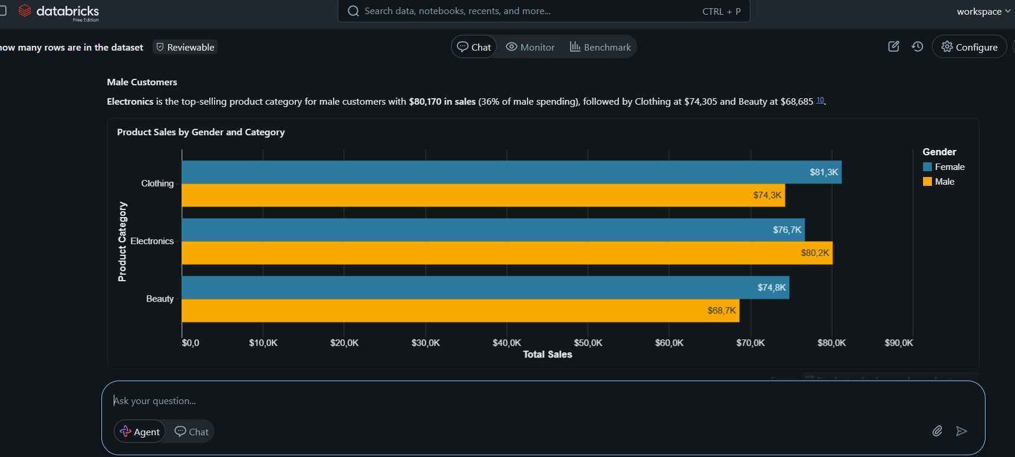

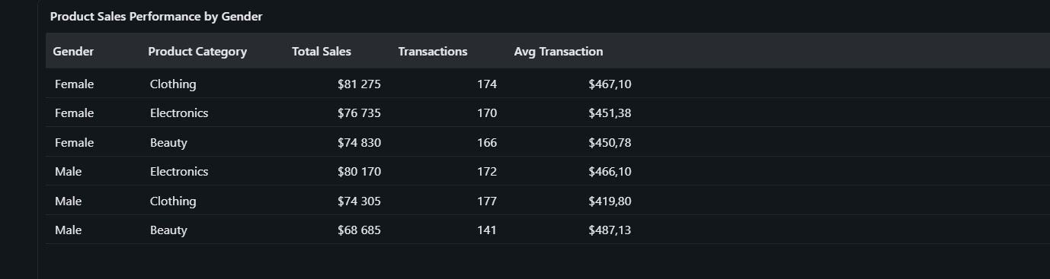

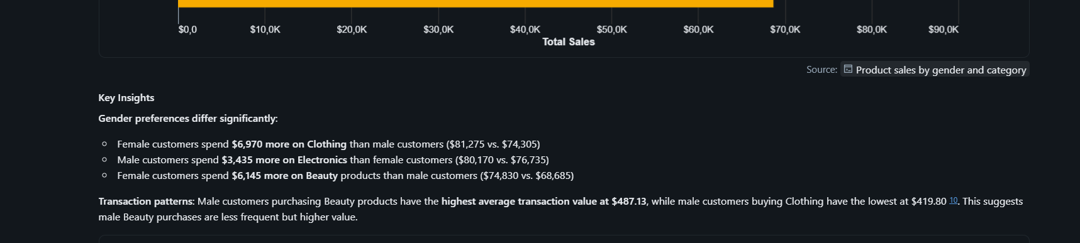

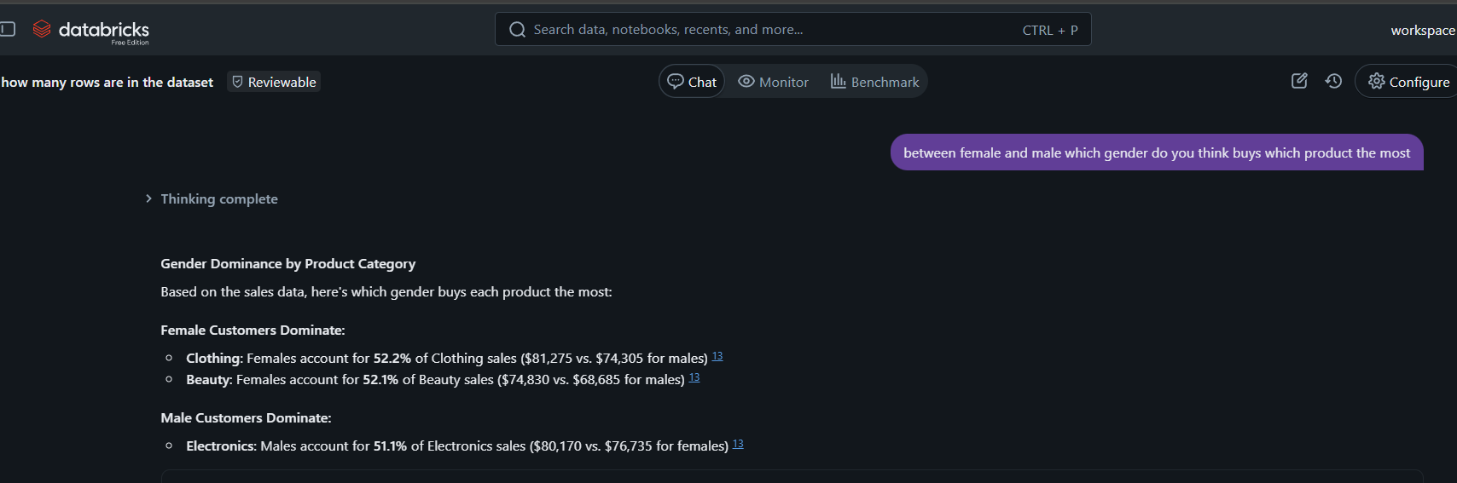
5.5. Between Female and Male which gender do you think buys the most products

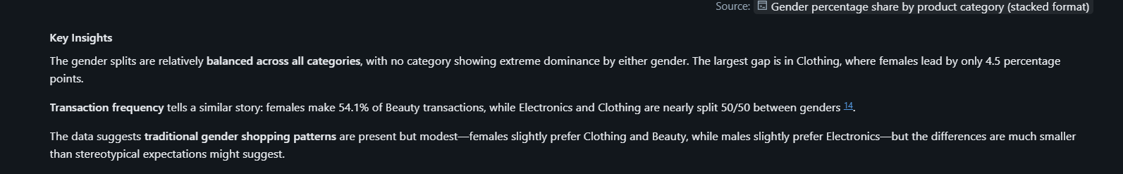
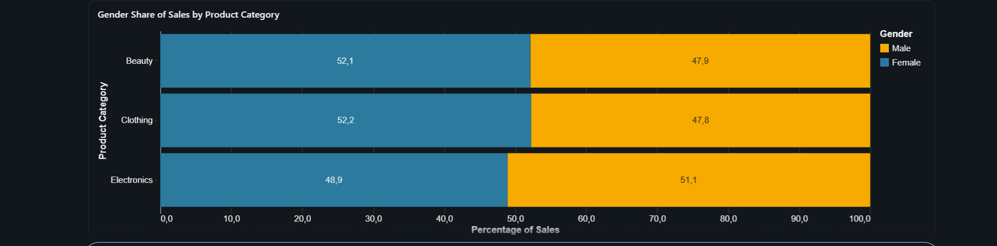

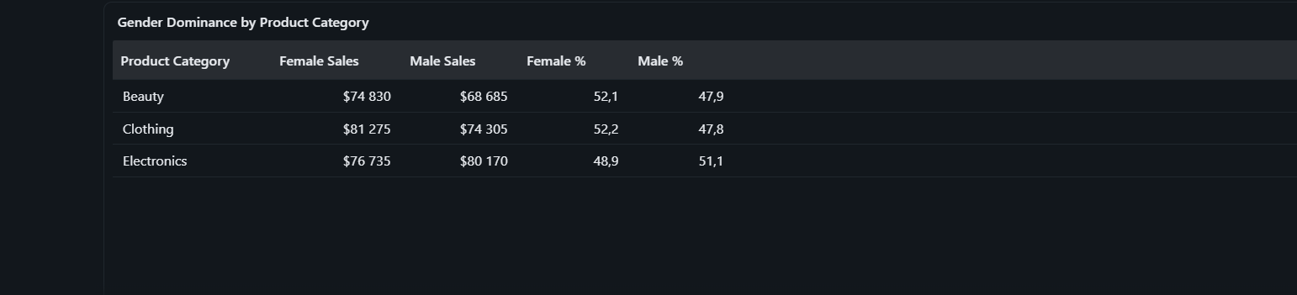
5.6. Identify the customers behaviours based on the sales dataset.

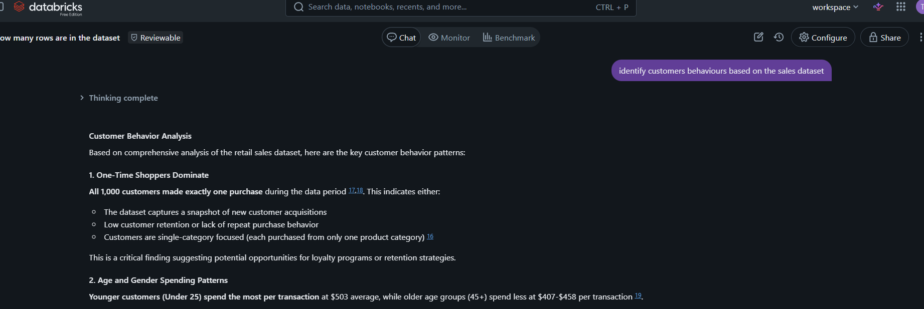

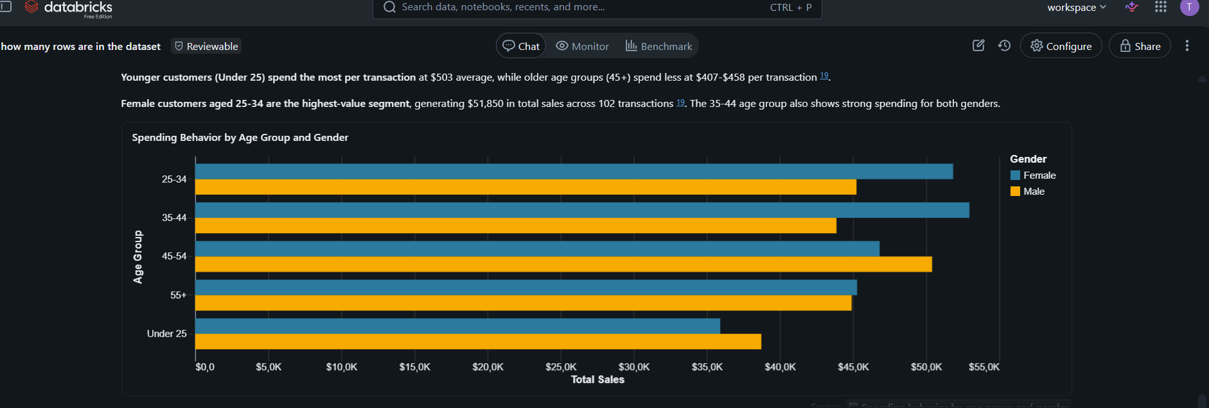

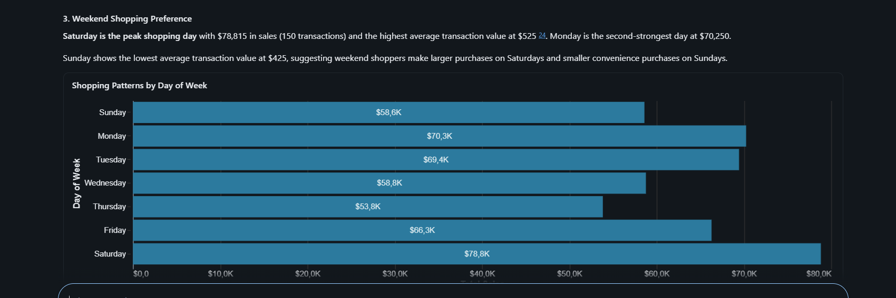

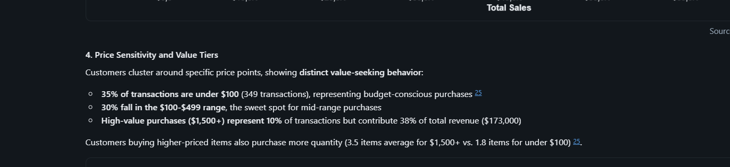

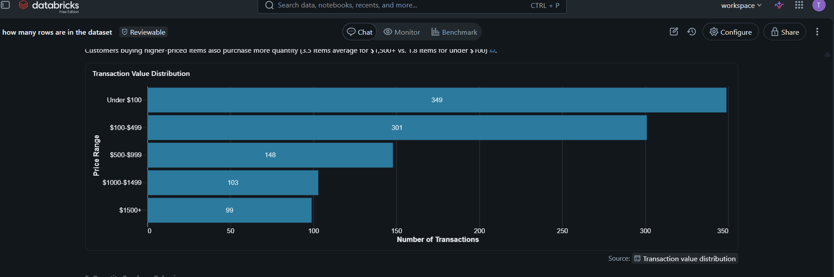

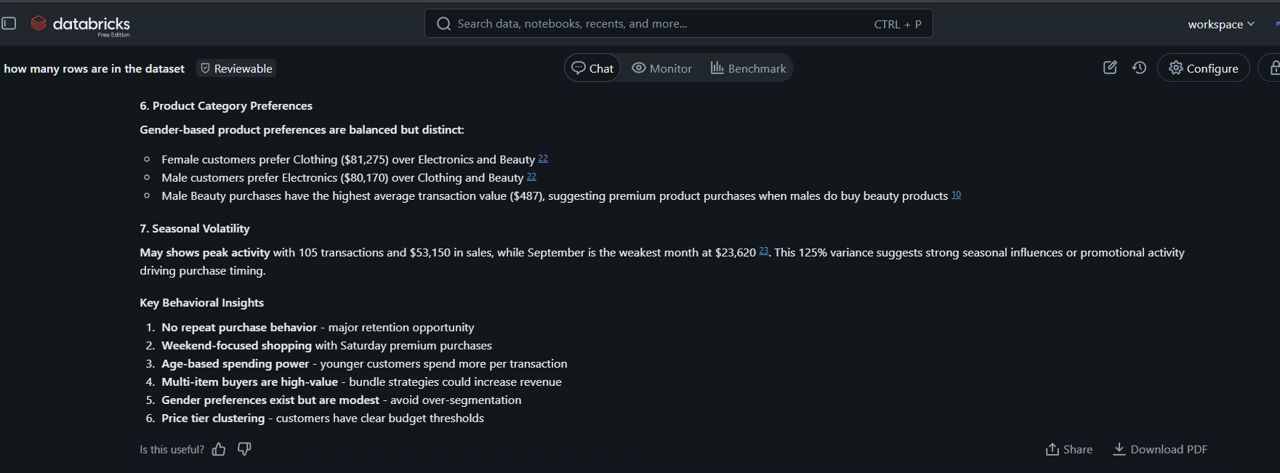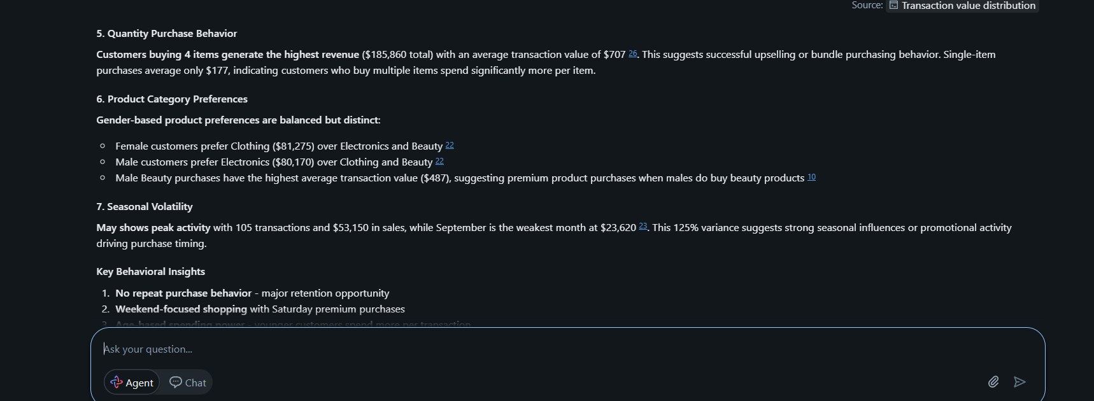

5.7 What is the average transaction value.
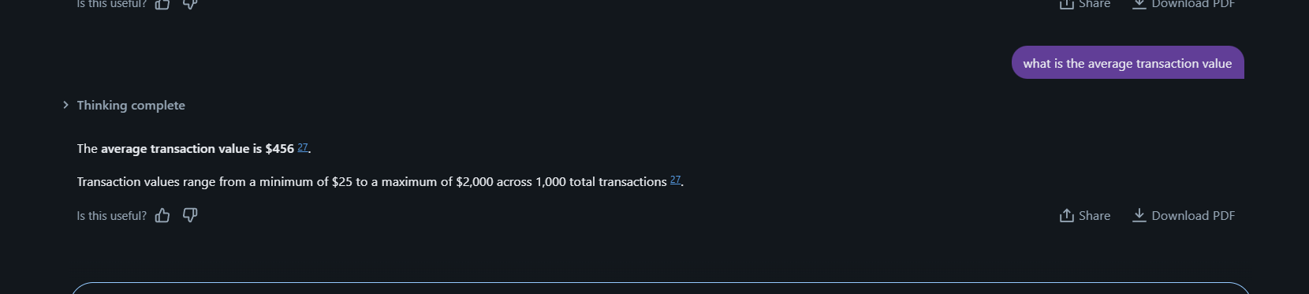

5.8 calculate the total amount for female and male.

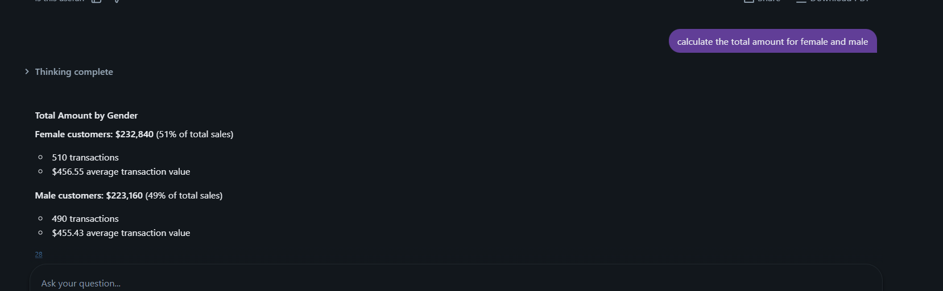

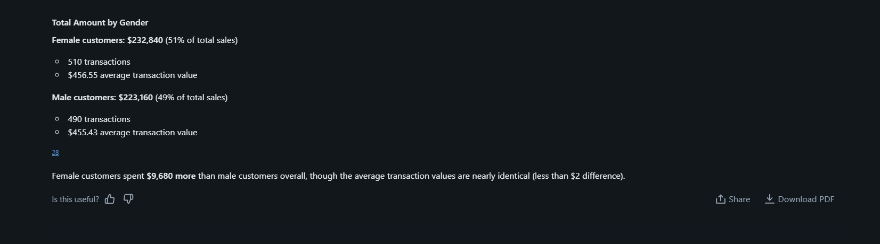

5.9 Show me all the dataset from the retail sales database.
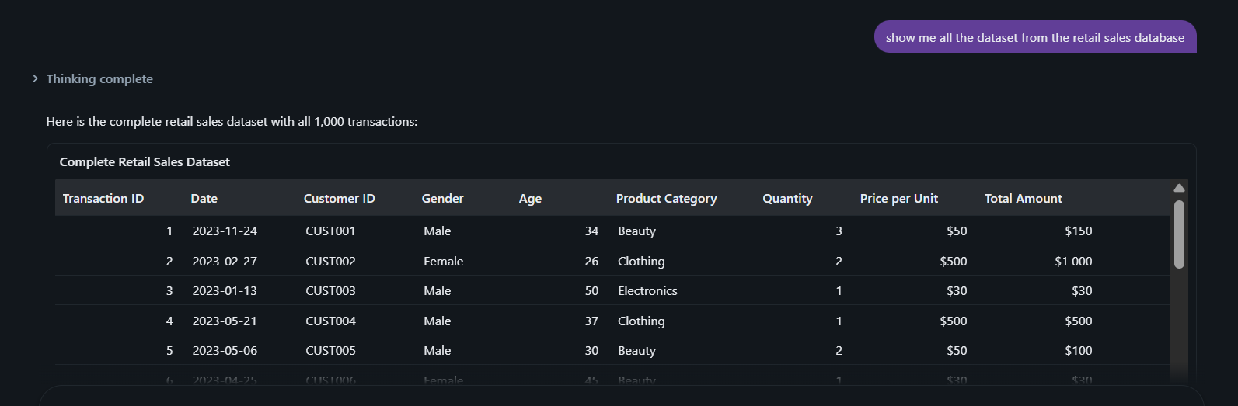
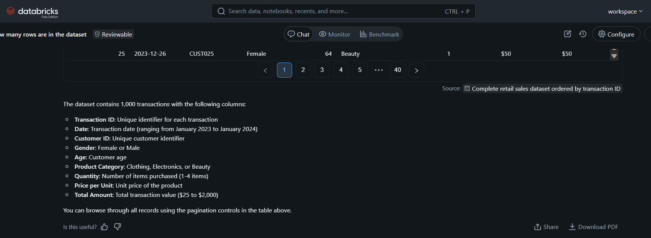
5.10 Count how many females do we have and how many males do we have on the dataset.
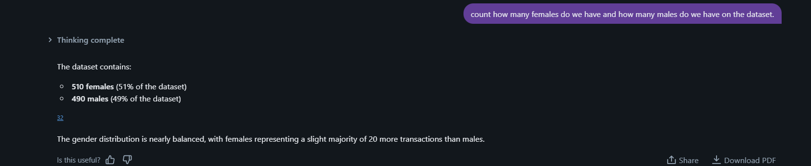

6.Validate your answers
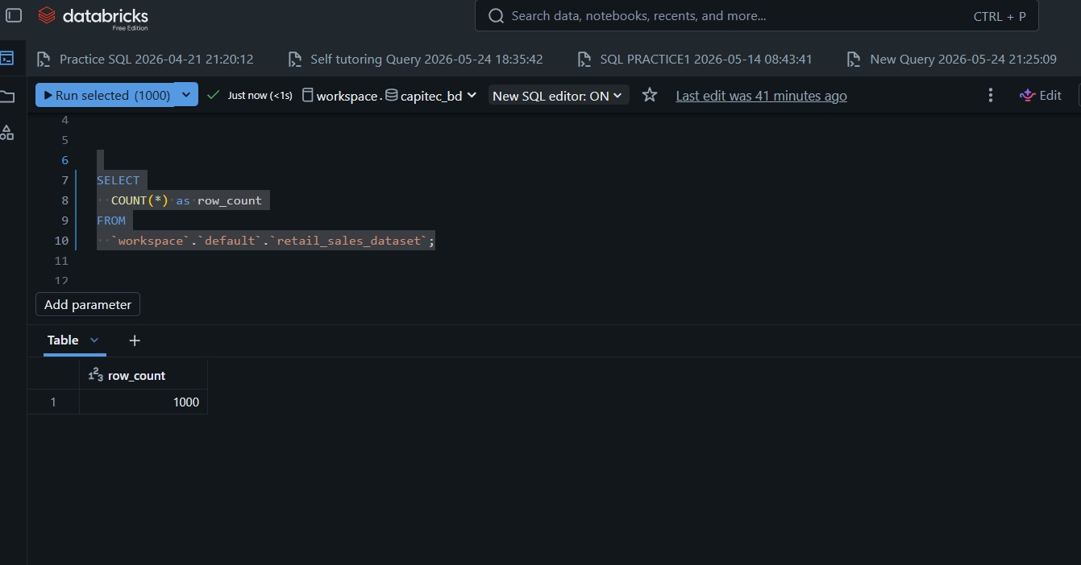
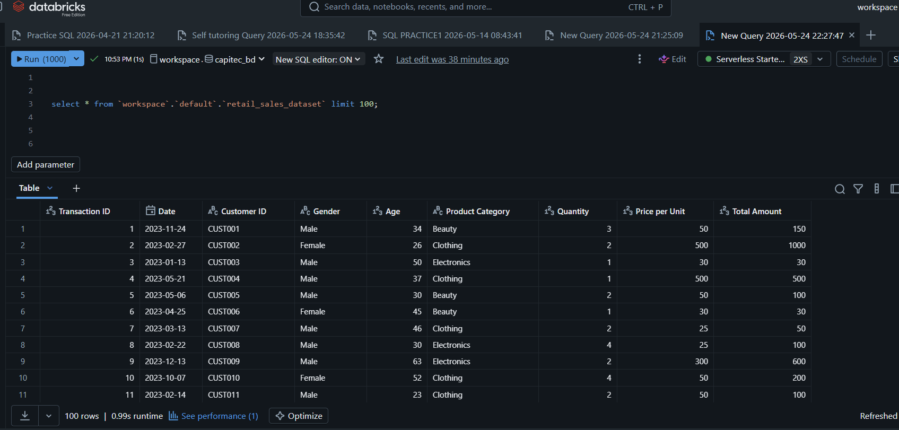

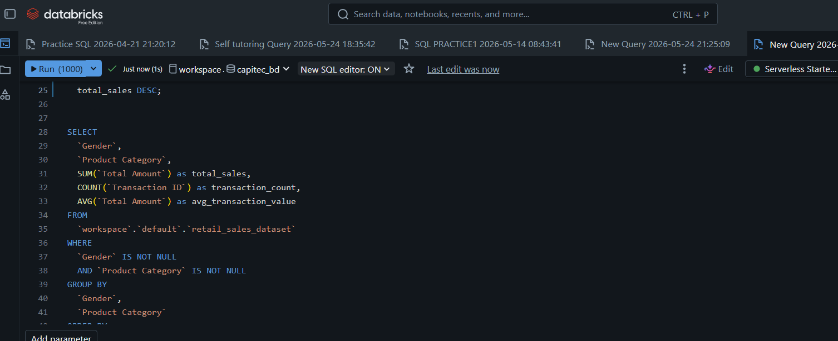
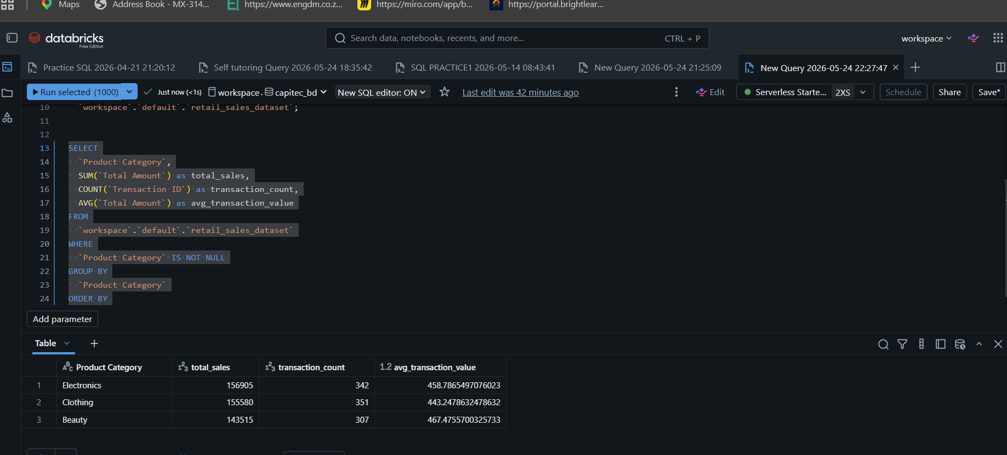

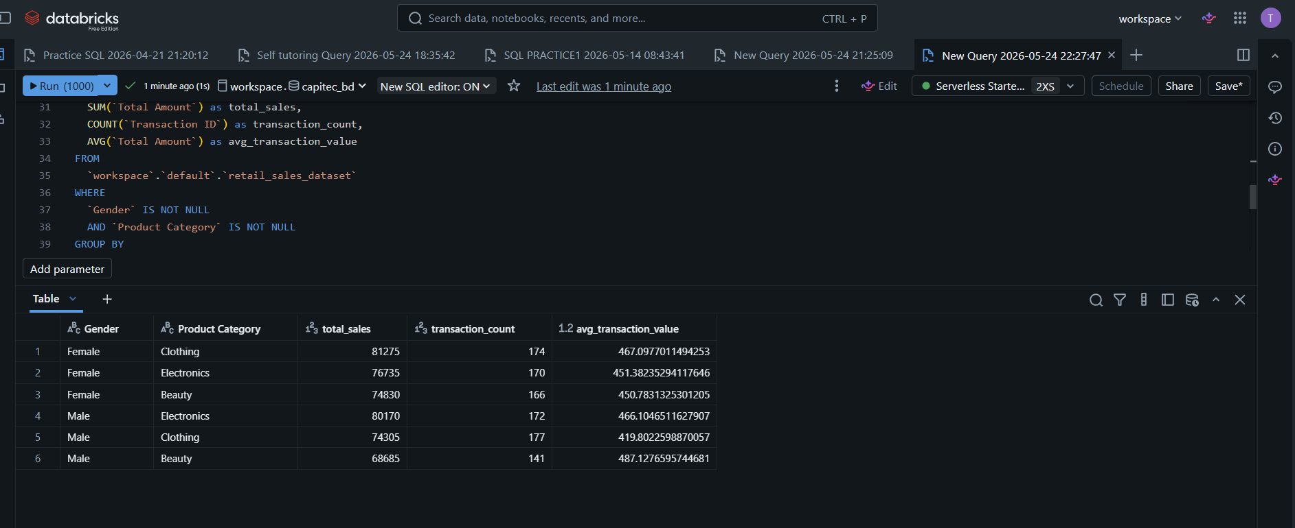

7. Conclusion
my conclusion/review based on Agent, i think the more I practice and learning how to use it I will understand it better and easy. Agent its helpful but it also requires us to know SQL, understand the insight of data that we are working on so that we will be able to fix the errors and identify the mistakes made by agents.

